COMPUTER NETWORKS

L-25 & 26

ASSIGNMENT-07

**Submitted By:**

Sudana shashi kiran

**Reg. Number:**

21BCE8644

**Submitted To:**

Prof Tekkali Chandana Gouri

**Simulate and analyze a network using RIP routing protocol**

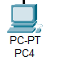

TAKE 2 PCS

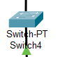

TAKE 2 SWITCHES

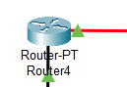

TAKE 2 ROUTERS

**AND CONNECT IN THE FOLLOWING MANNER AS MENTIONED BELOW**

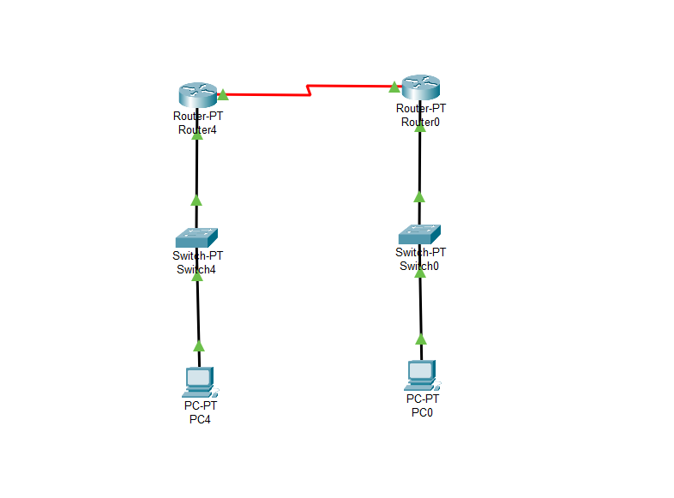

**CONFIGURE THE IP ADDRESS AND DEFAULT GATE WAY :**

IP ADRESSES OF PC_4: 122.163.1.2

DEFAULT GATEWAY : 122.163.1.1

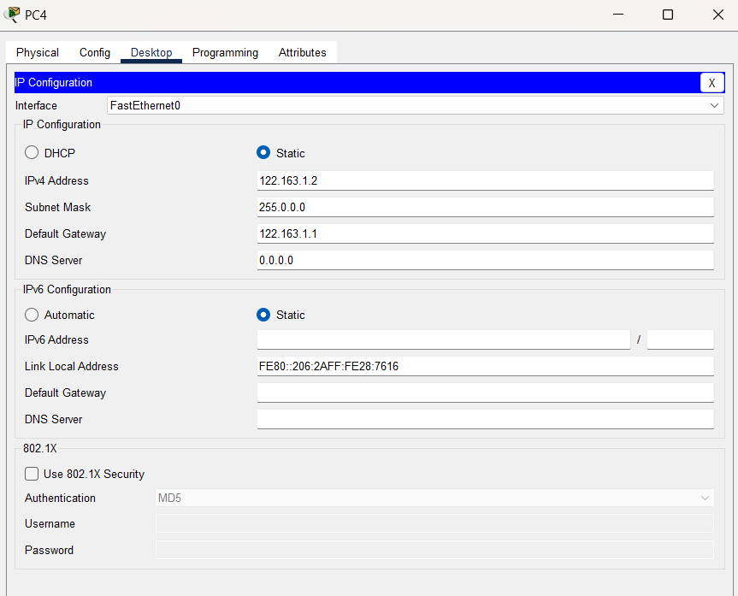

IP ADDRESS OF PC_0: 192.155.1.2

DEFAULT GATEWAY : 192.155.1.1

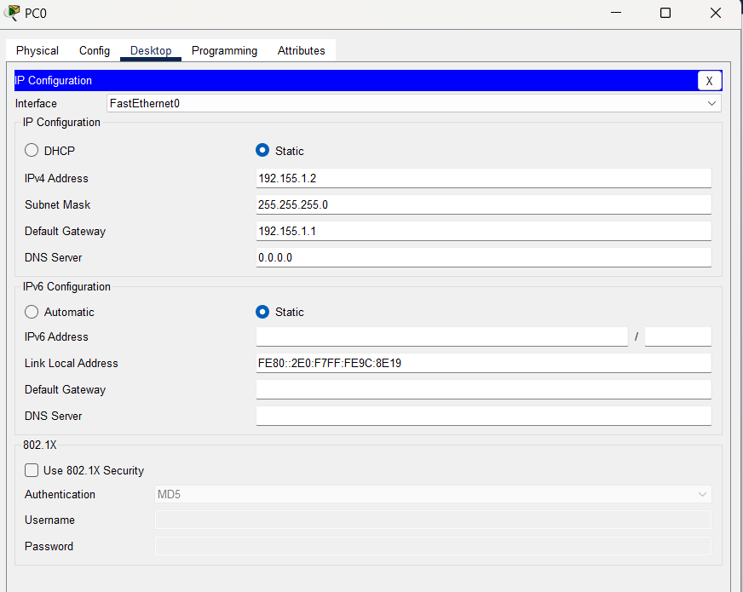

**CONFIGURE IP FOR ROUTERS :**

IP ADRESSES OF FASTETHERNET0/0 : 122.163.1.1

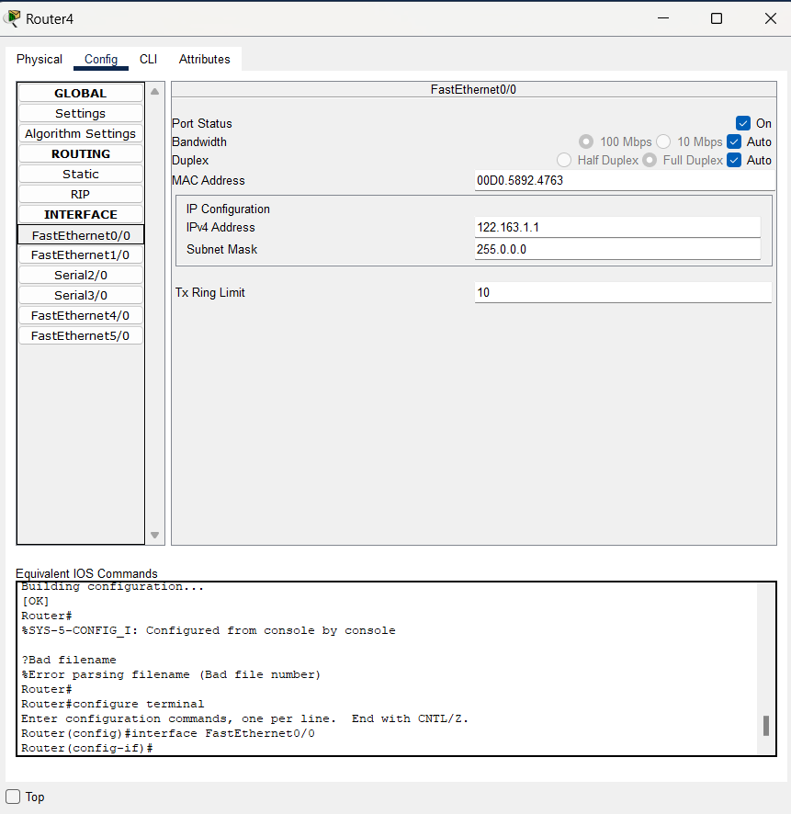

IP ADRESSES OF SERIAL 2/0: 10.10.1.2

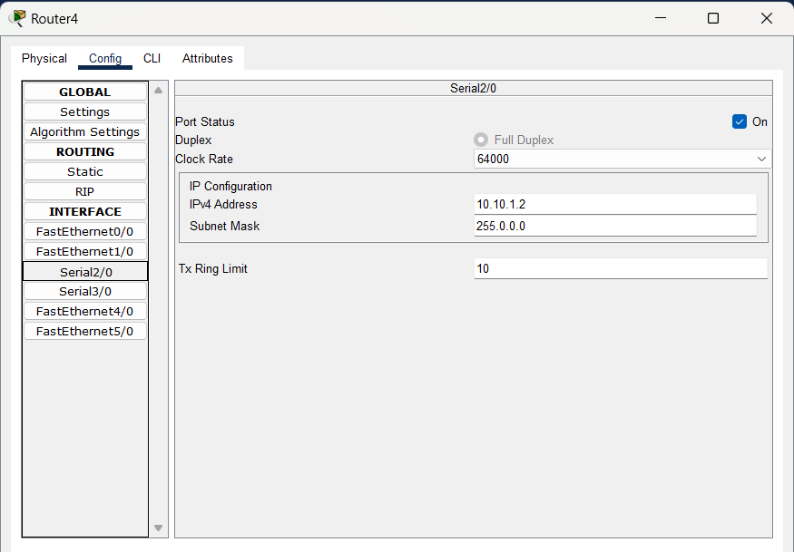

IP ADDRESS OF FASTETHERNET0/0: 192.155.1.1

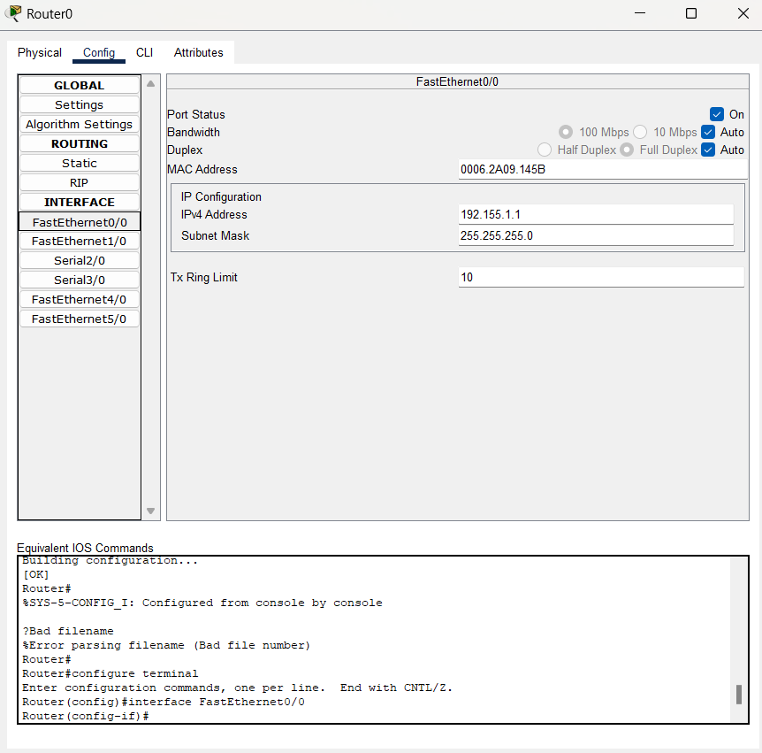

IP ADDRESS OF SERIAL 2/0: 192.155.1.2

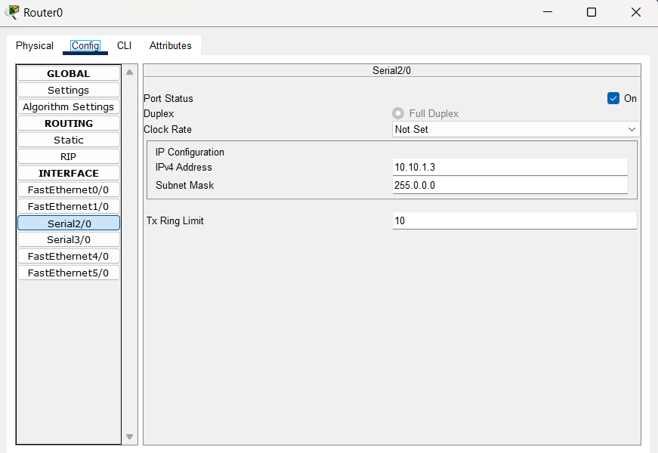

**ADD IP ADRESS IN RIP FOR BOTH THE ROUTERS:**

**FOR ROUTER-4:**

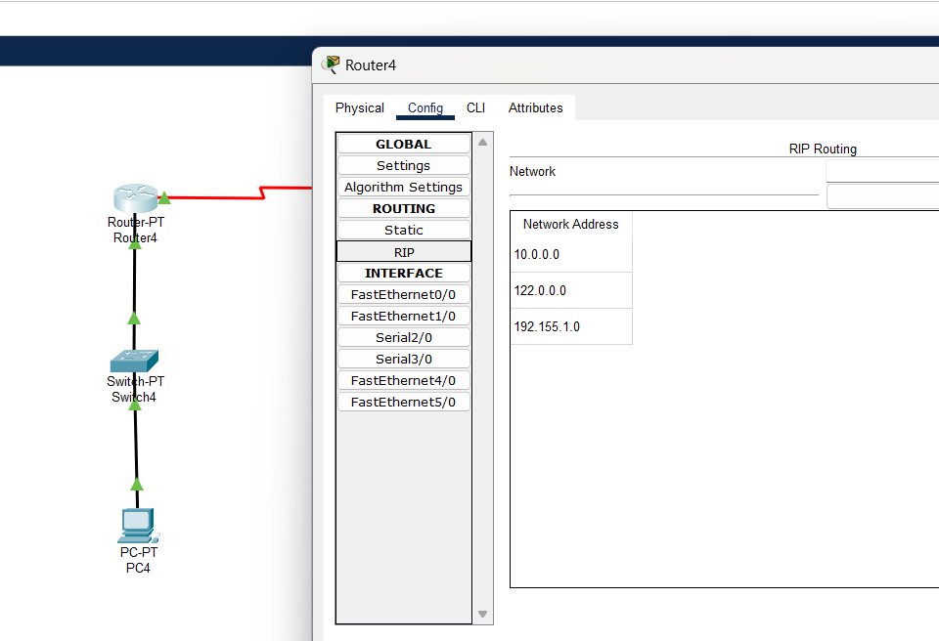

**FOR ROUTER-0:**

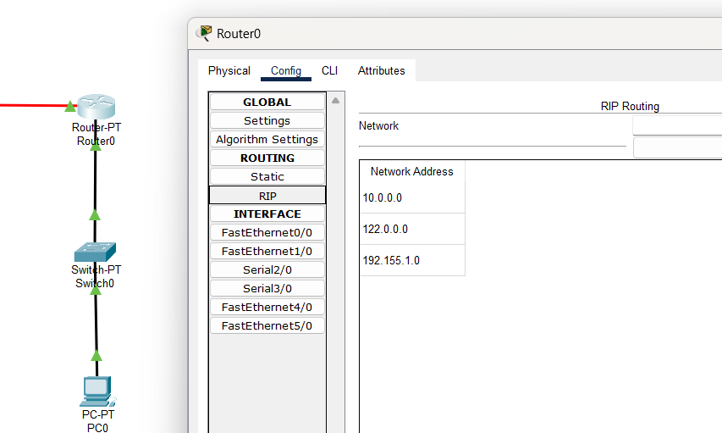

**SEND THE MESSAGE FROM PC4 TO ROUTER4 :**

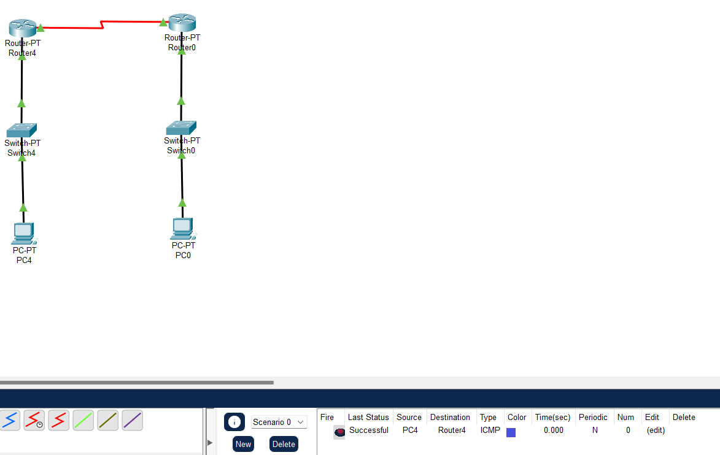

**SEND THE MESSAGE FROM PC4 TO ROUTER4 :**

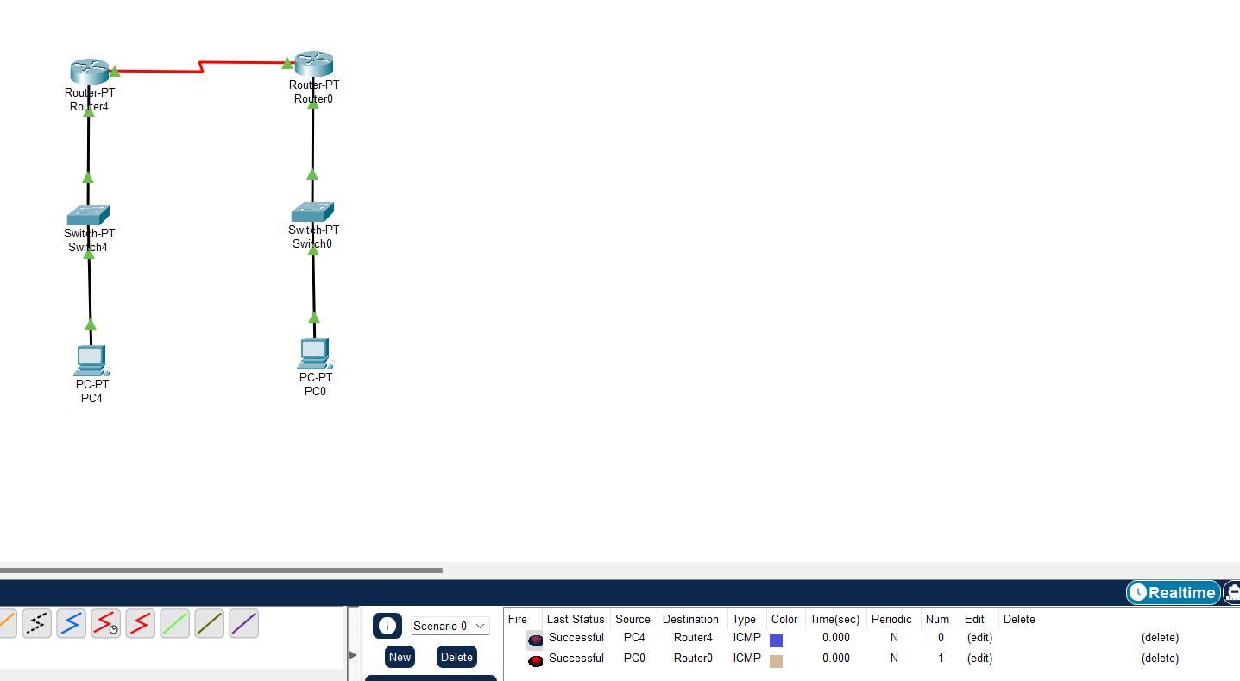

**AS WE CAN SEE BOTH THE MESSAGES SEND SUCESSFULLY:**

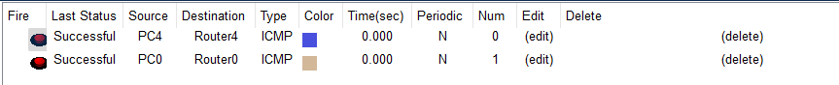

**SEND MESSAGE FROM PC-4 TO PC-0:**

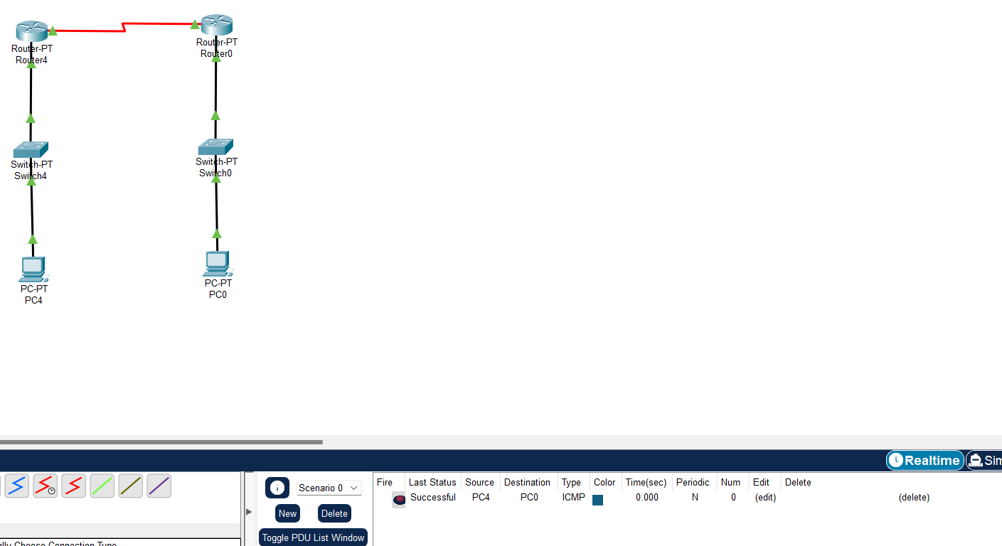

**SEND MESSAGE FROM PC-4 TO PC-0:**

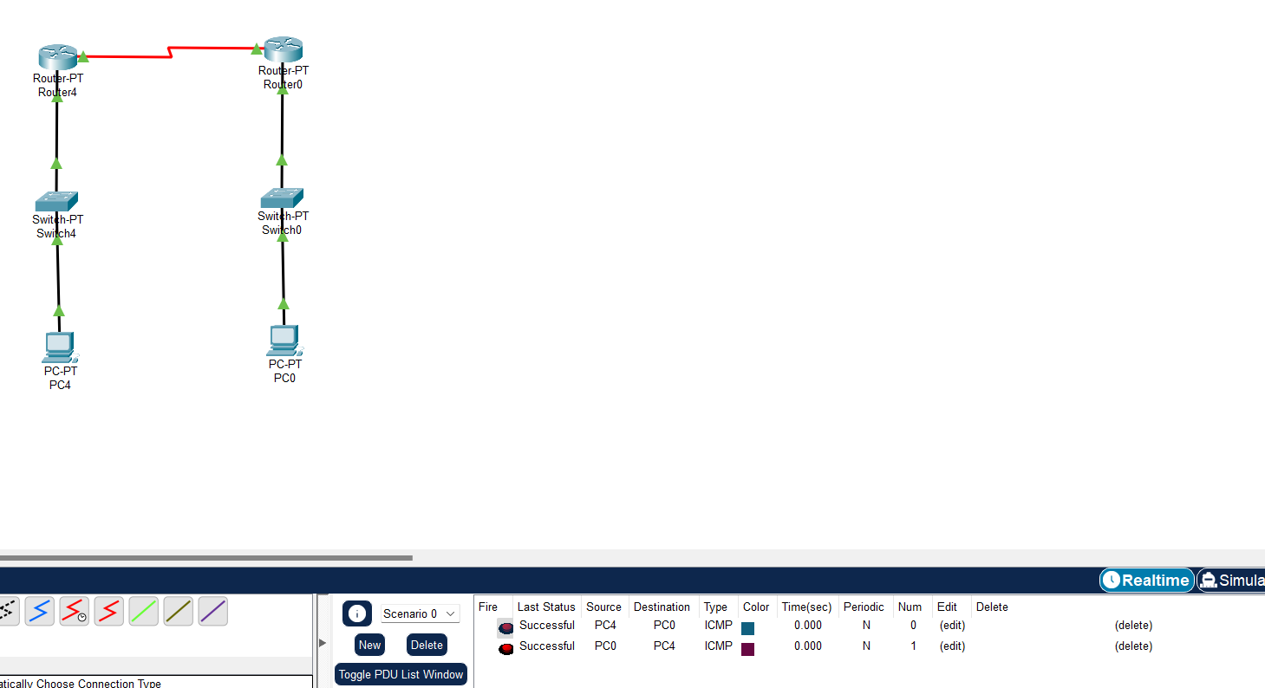

**AS WE CAN SEE BOTH THE MESSAGES SEND SUCESSFULLY:**

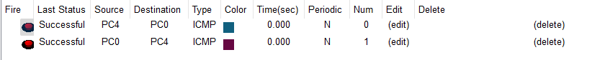

**SIMULATION:**

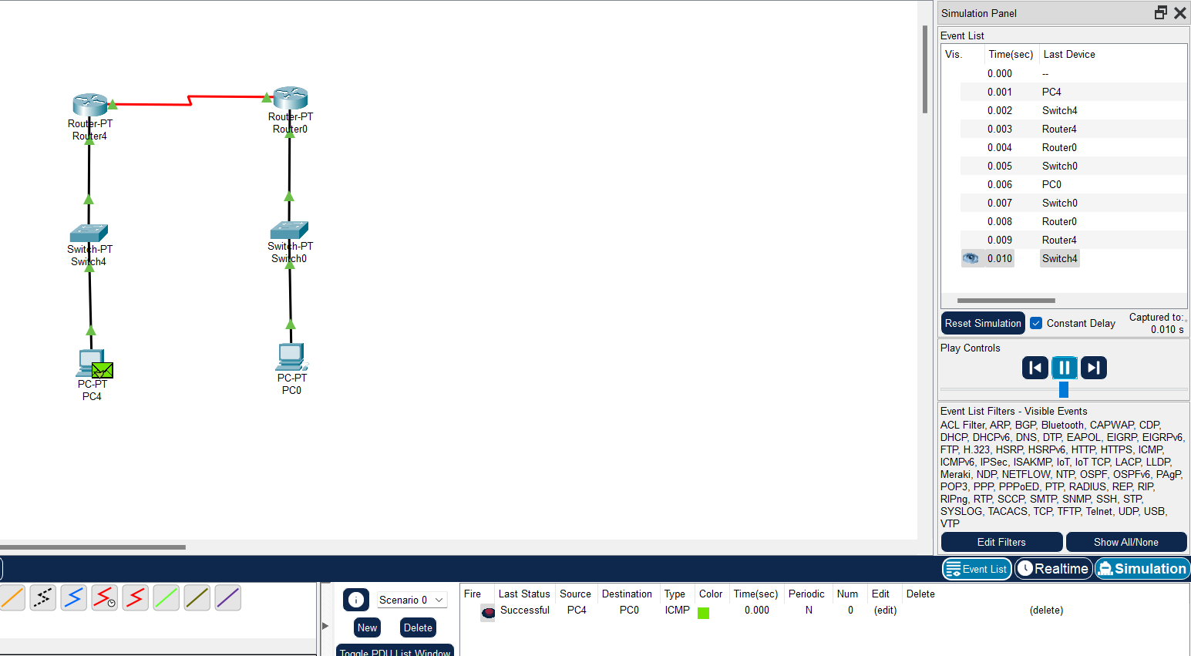

**AS WE CAN SEE BOTH THE MESSAGES SEND SUCESSFULLY:**

